The first screenshot shows all the bank accounts.
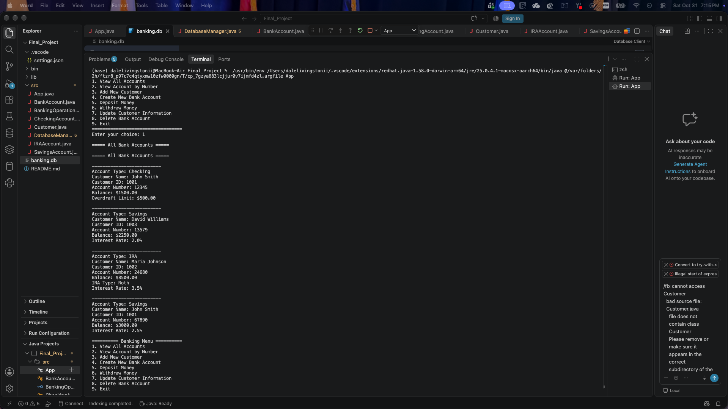
This screenshot shows a view of a single account.
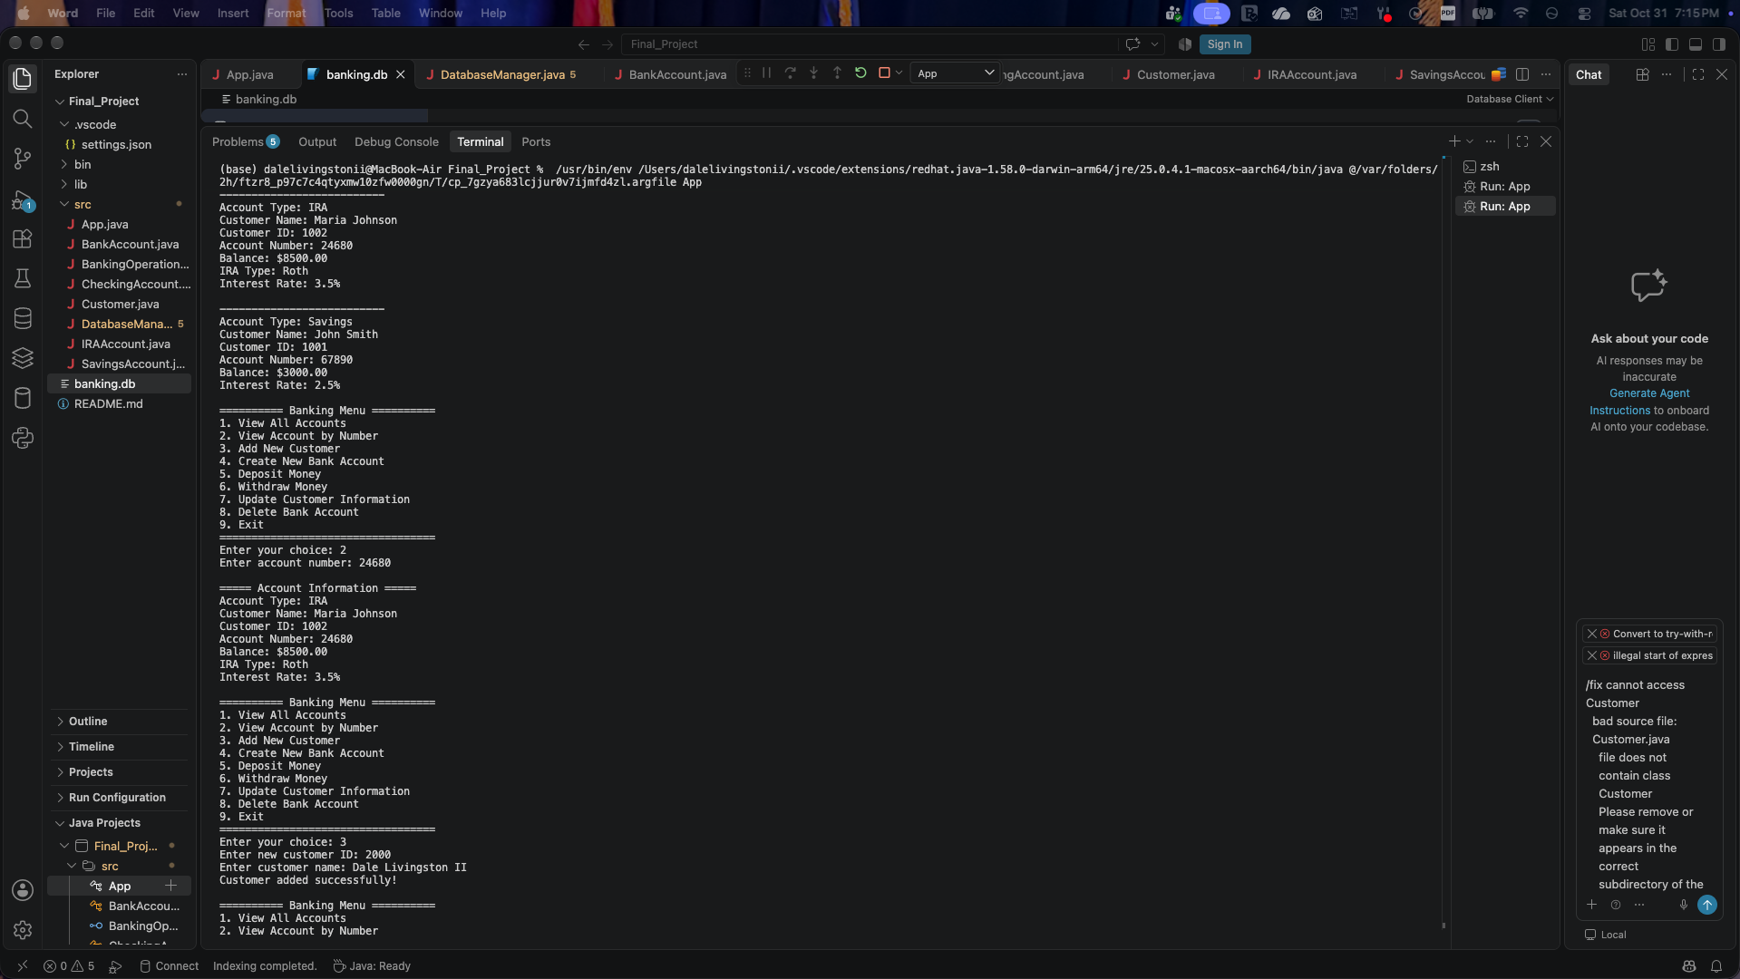
This screenshot shows creating a new customer.
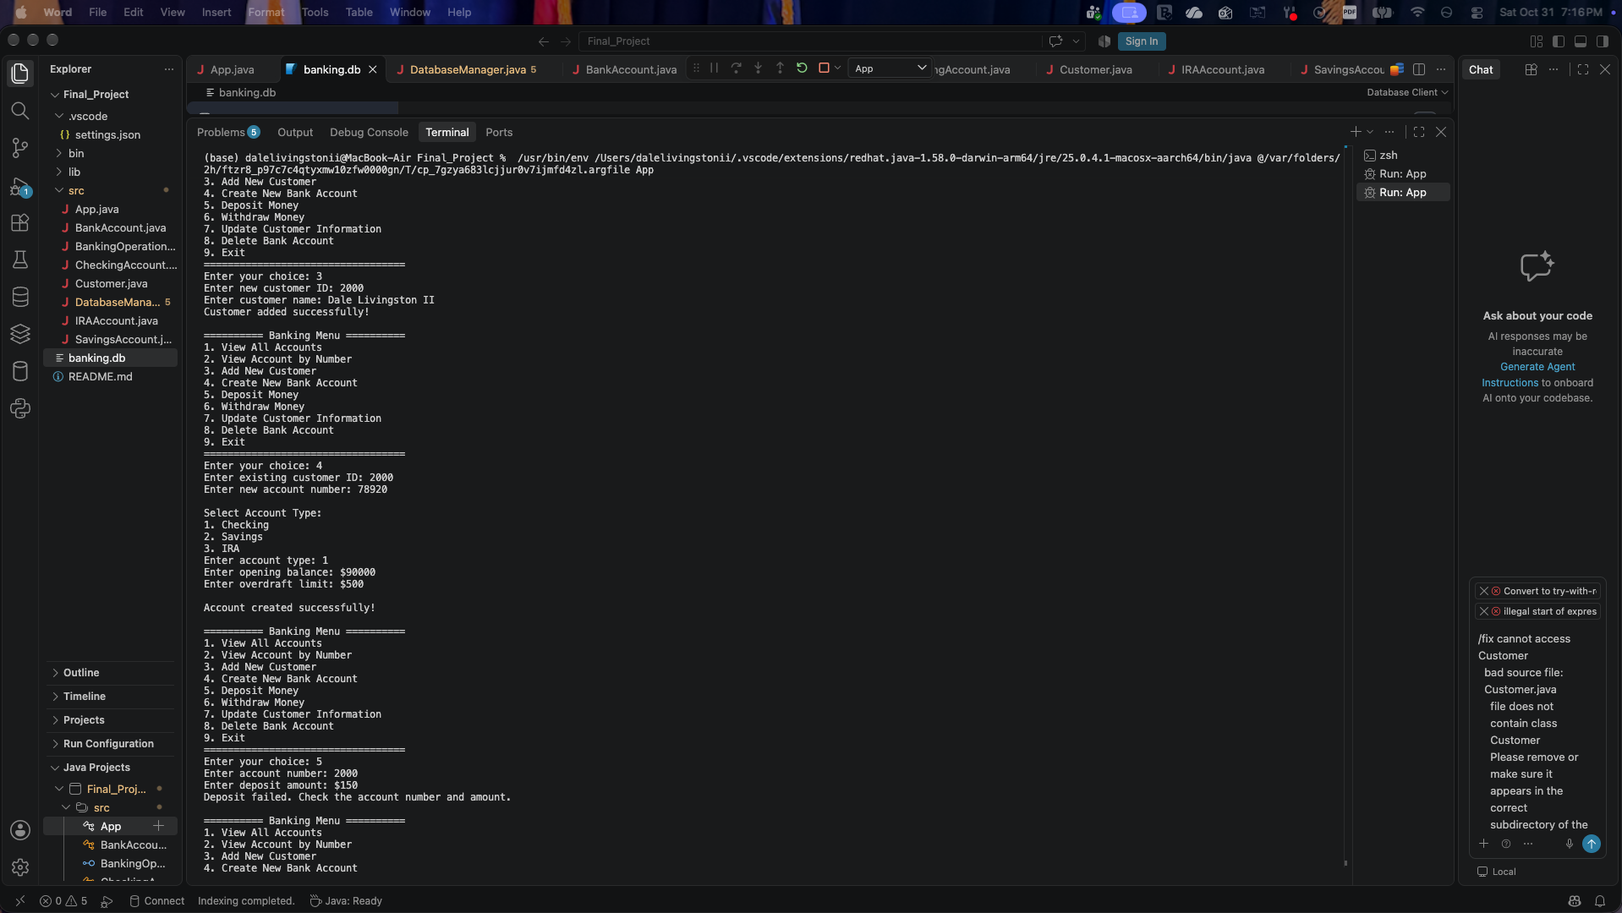
This screenshot shows creating a new account.
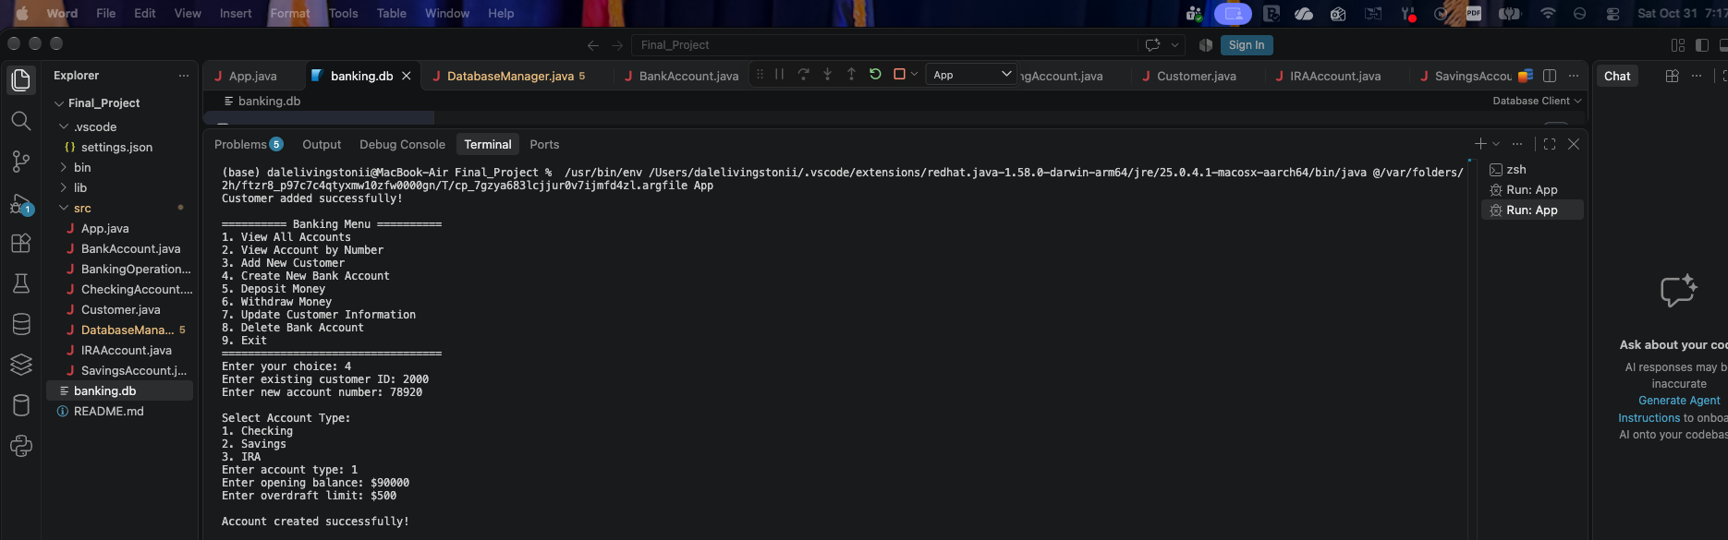
This screenshot shows depositing and withdrawal from the account.
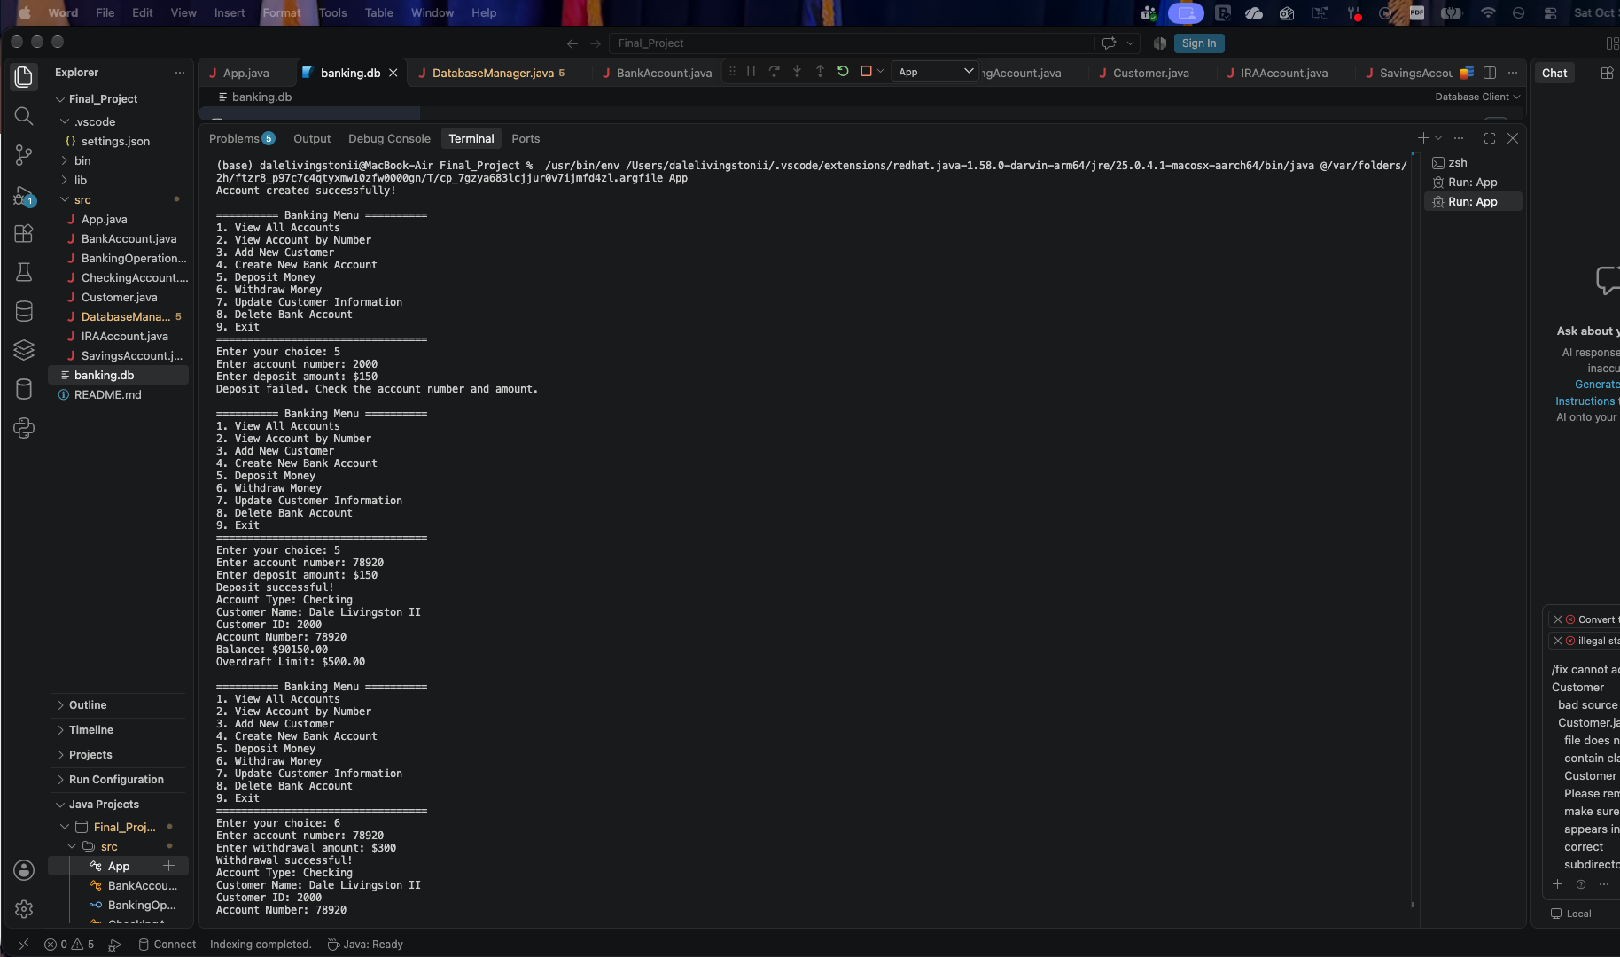
This screenshot shows updating the customer information and deleting an account
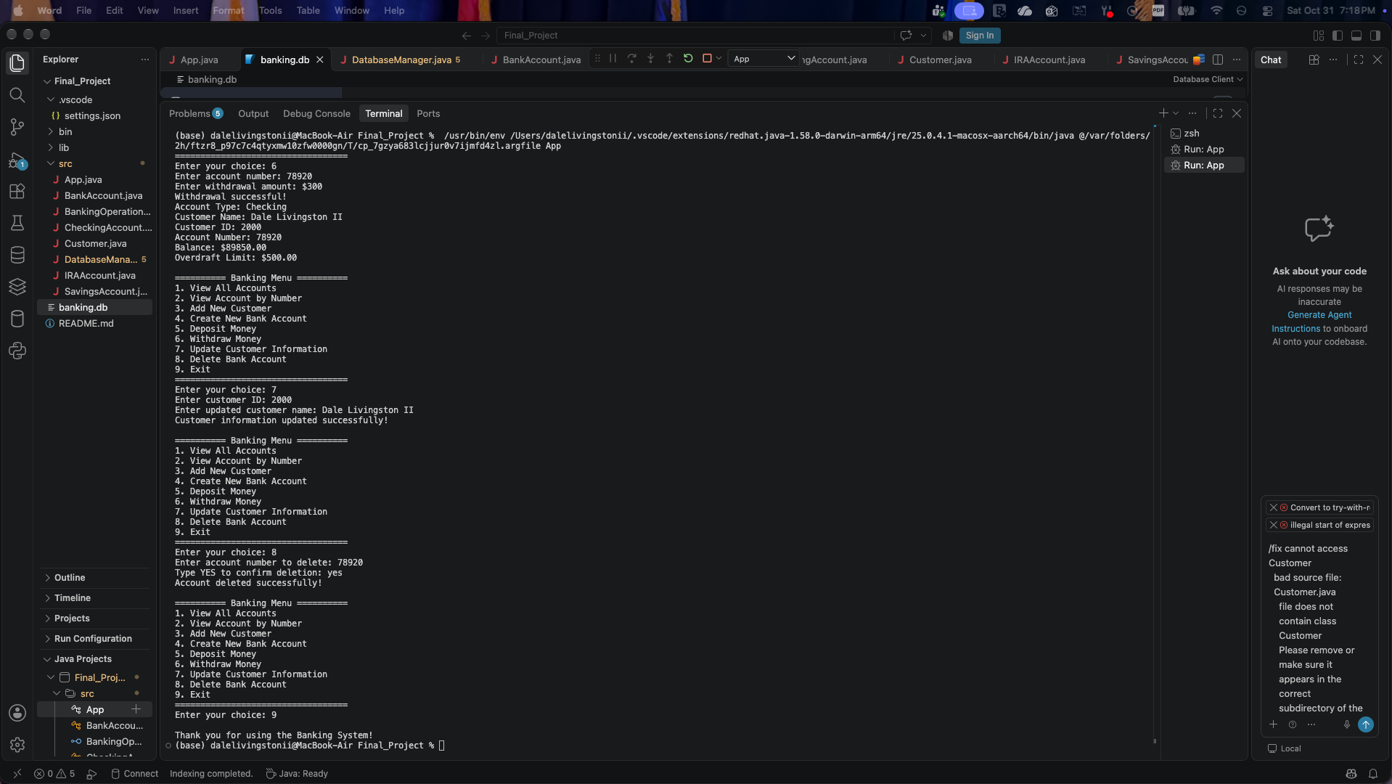
This screenshot shows the customer table with the primary key being the customer_id
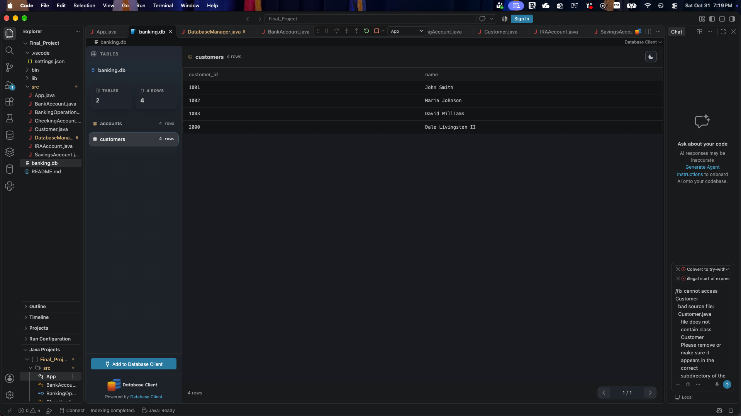
This screenshot shows the different accounts with the primary key being the account_number.
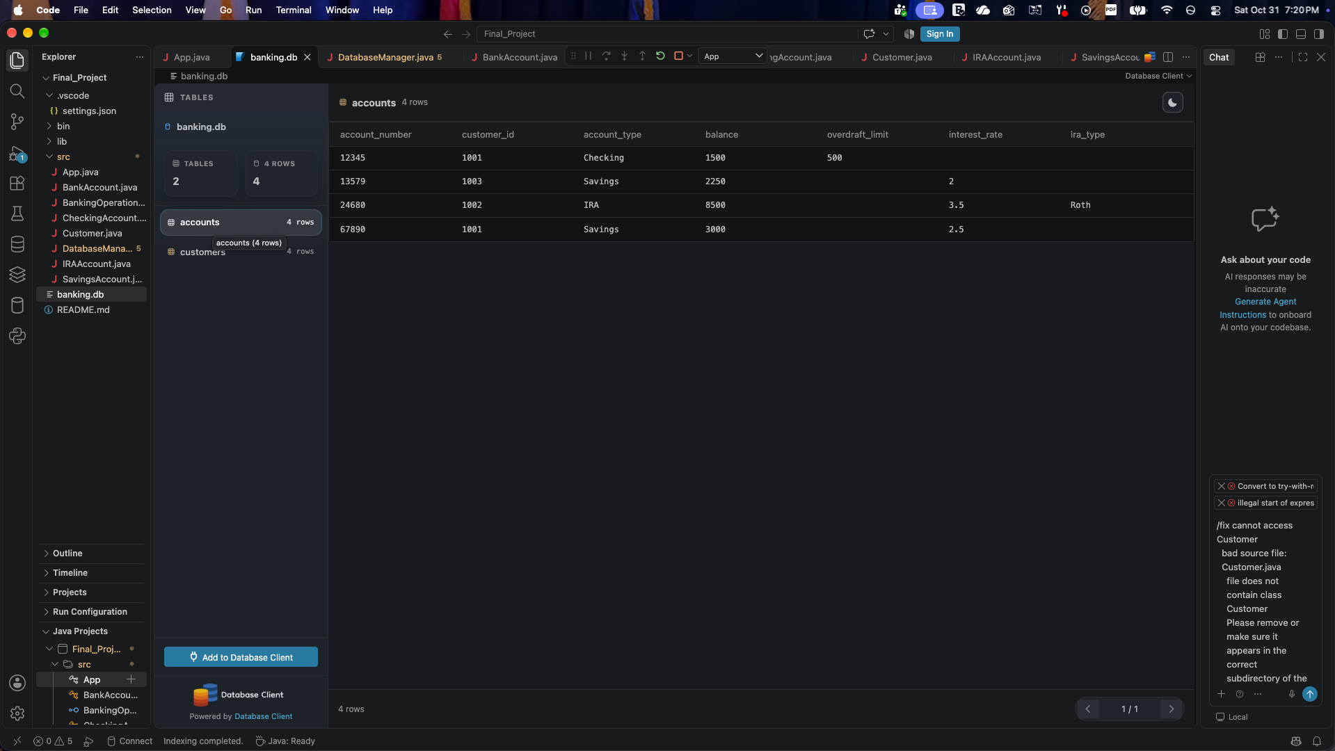
Here is the screenshot creating the customers table.
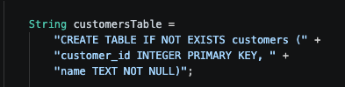
Here is the screenshot creating the accounts table.


